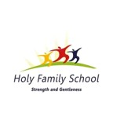
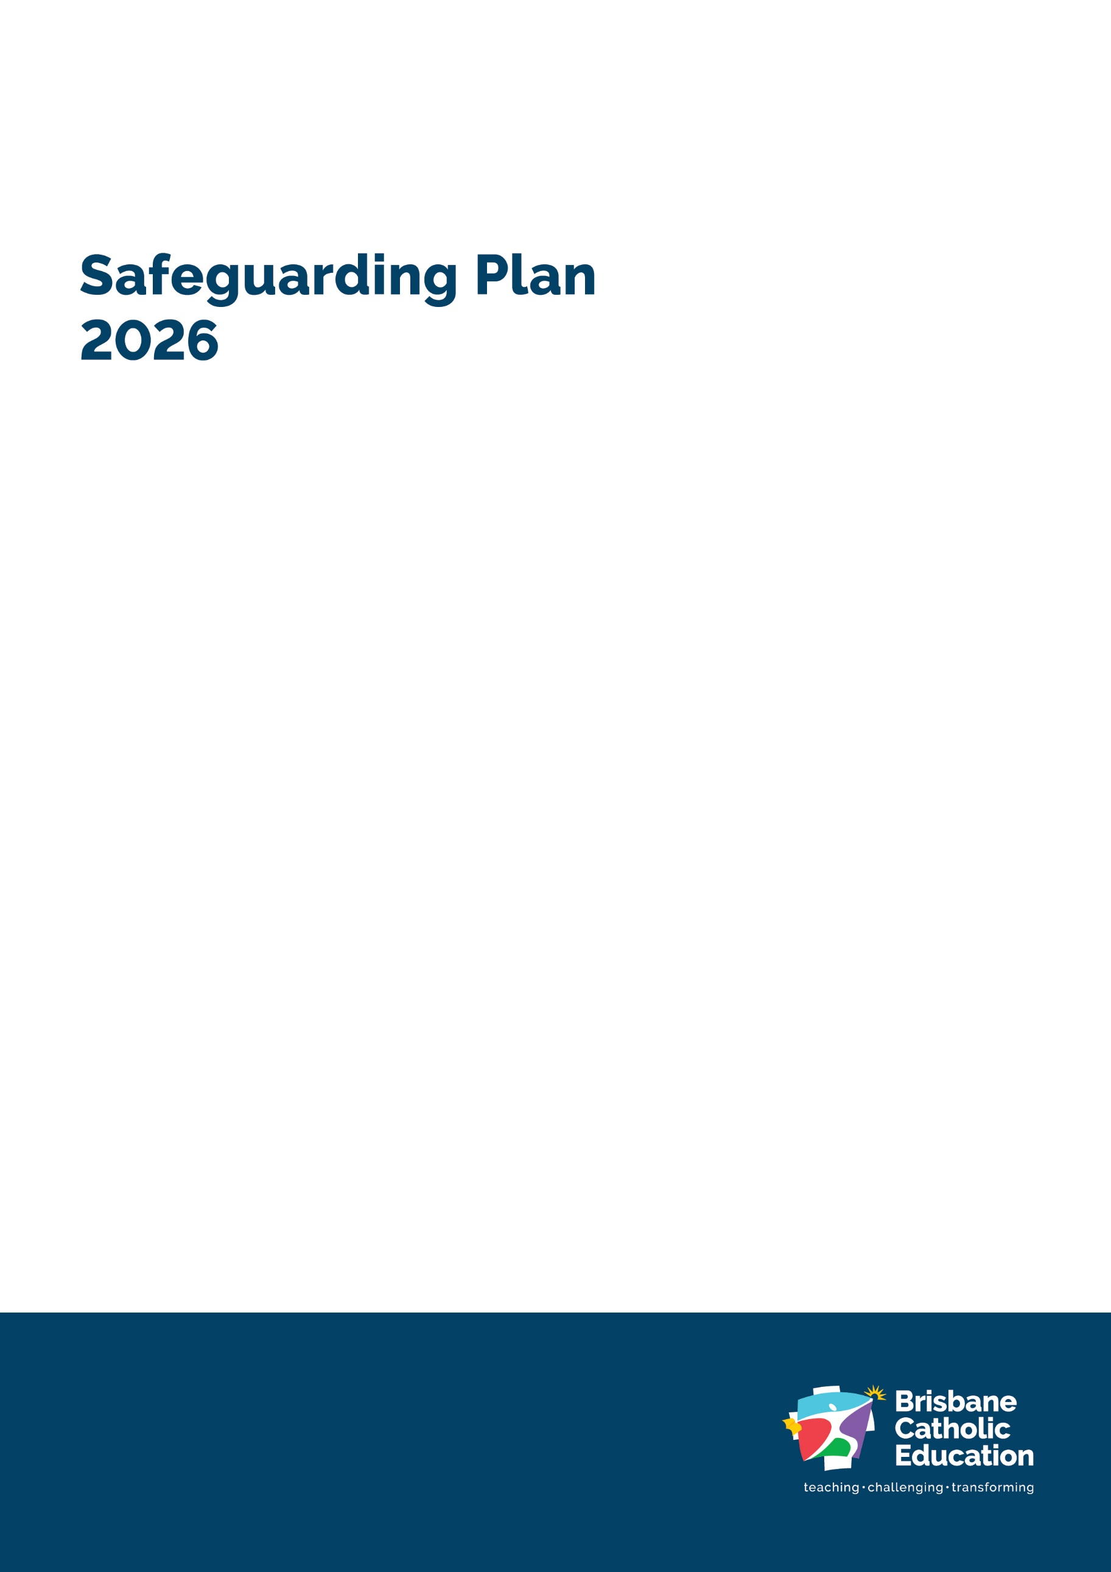
Version: V1
Last updated: 8th September 2026
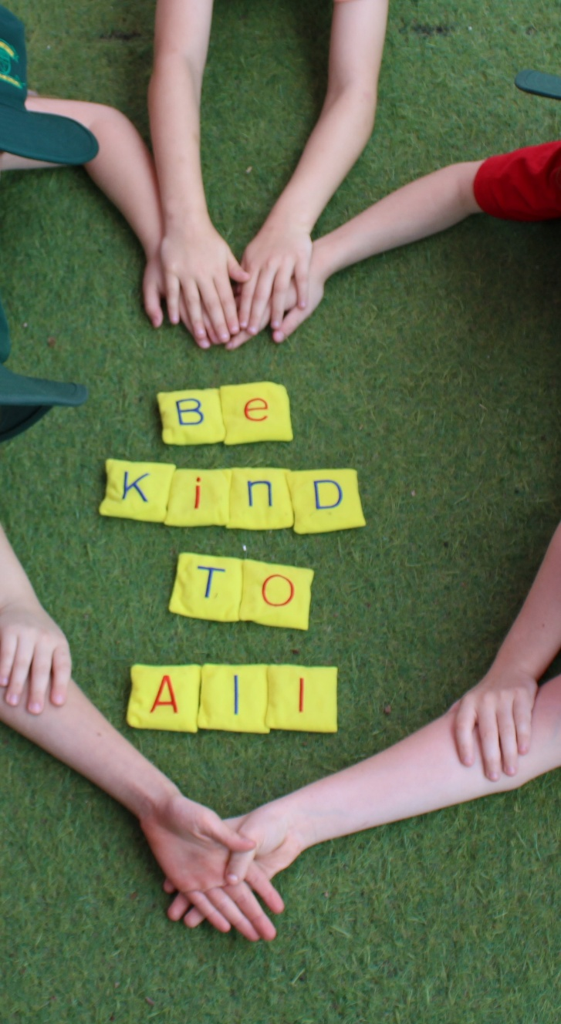
Holy Family Primary School


Our Safeguarding Commitment
As an agency of the Archdiocese of Brisbane, we have a zero tolerance for all forms of abuse and are committed to safeguarding everyone involved in its activities, ministries, and services. The safety and wellbeing of children and adults-at-risk is paramount.

Accessibility

Brisbane Catholic Education is committed to providing accessible
services to people from all culturally and linguistically diverse backgrounds. If you have difficulty understanding this document, you can contact Translating and Interpreting Service National on 13 14 50 to arrange for an interpreter to translate it for you.

Contact for enquiries

Holy Family Primary School,
37 Ward Street, Indooroopilly,
Yuggera and Turrbal Country,
(07) 3870 9600
www.holyfamilyps.qld.edu.au

Attributions
Artwork: Ngulli Gumera artwork by Waylene Currie of WRLC Arts, 2025.
Cover: (c) Brisbane Catholic Education, Holy Family, 2026
Page 4: (c) Brisbane Catholic Education, Holy Family, 2026

© The State of Queensland (Queensland Family and Child Commission) Guidelines for implementing the Universal Principle and Child Safe Standards in Queensland. These Guidelines and the related symbols contained in this work are adapted from material licensed under the Creative Commons Attribution (CC BY) 4.0 International licence.


Acknowledgement of Country
We acknowledge the First Peoples that we learn from the Yuggera and Turrbal Peoples and thank the elders past and present for sharing the ancient wisdom of their ancestors.
We continue to be enriched by their knowledge and connection to Country.
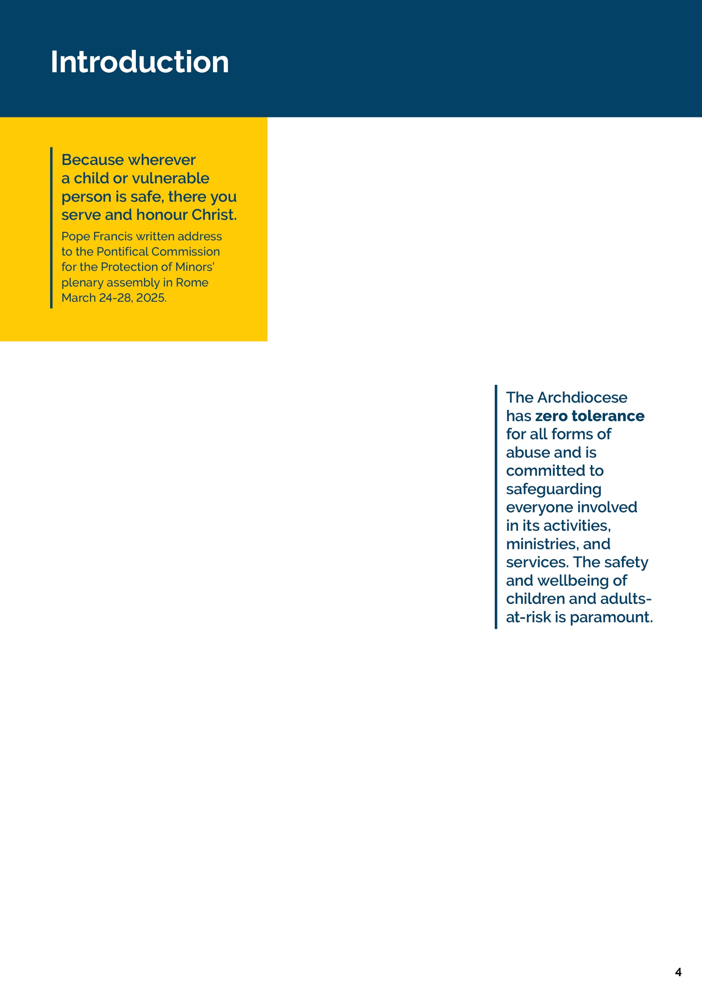
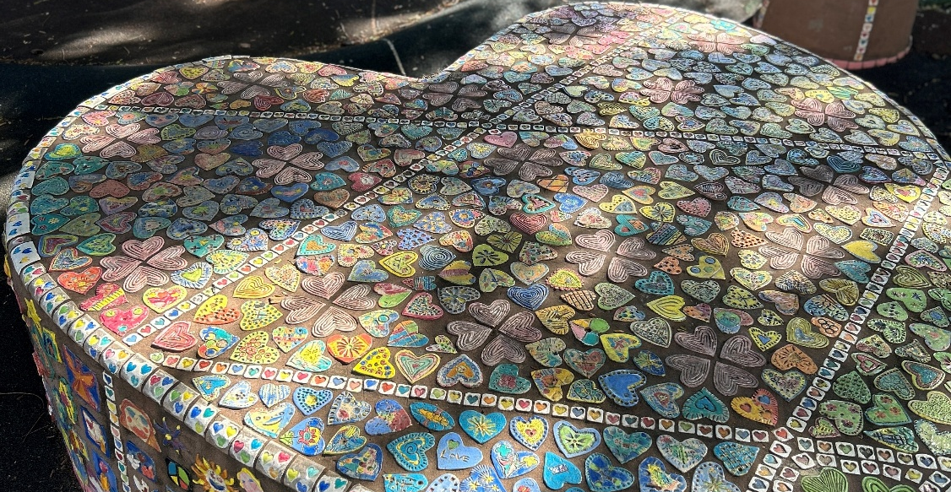
Holy Family Primary School, Indooroopilly, is committed to creating environments where children and young people feel protected, valued, and heard. Safeguarding is a shared responsibility, and every child has the right to grow and thrive free from harm.
We are guided by our Christian Catholic Tradition and the teachings of Jesus Christ who advocated for the protection of children and the marginalised. Our mission to teach, challenge and transform through our educational endeavours is actioned by Catholic Social Teaching, as part of the Archdiocese of Brisbane.
The Queensland Government recently introduced new Child Safe Standards. These Standards clearly outline what child safe organisations must do to create environments where children are protected, respected and able to speak up. They focus on building safe, welcoming cultures, hearing and valuing children’s voices, working closely with families, celebrating diversity, making sure the right people work with children, responding quickly to concerns, and always looking for ways to improve safety.
Throughout 2026, our school will review its compliance against the new Child Safe Standards using a phased approach in line with Queensland Family and Child Commission guidelines. We will review, self-assess and report against selected Standards each term, building towards full implementation and continuous improvement across all Standards by the end of the year. This staged process allows Holy Family Primary School to embed the Standards meaningfully and ensure our practices reflect the needs, voices and safety of our students.
As a Catholic school within the Archdiocese of Brisbane, we honour the Archdiocesan Safeguarding Commitment and uphold the values of Catholic education in our safeguarding practices.
This School Safeguarding Plan is developed in consultation with students, families, and employees, and is contextualised to our local school environment. It reflects our commitment to continuous improvement, cultural safety, and child-centred practice, and is supported by both Brisbane Catholic Education policies and procedures and school-specific safeguarding actions. Further Information about BCE wide practices can be accessed here.
For more information or to request accessible formats, please contact the school Principal.
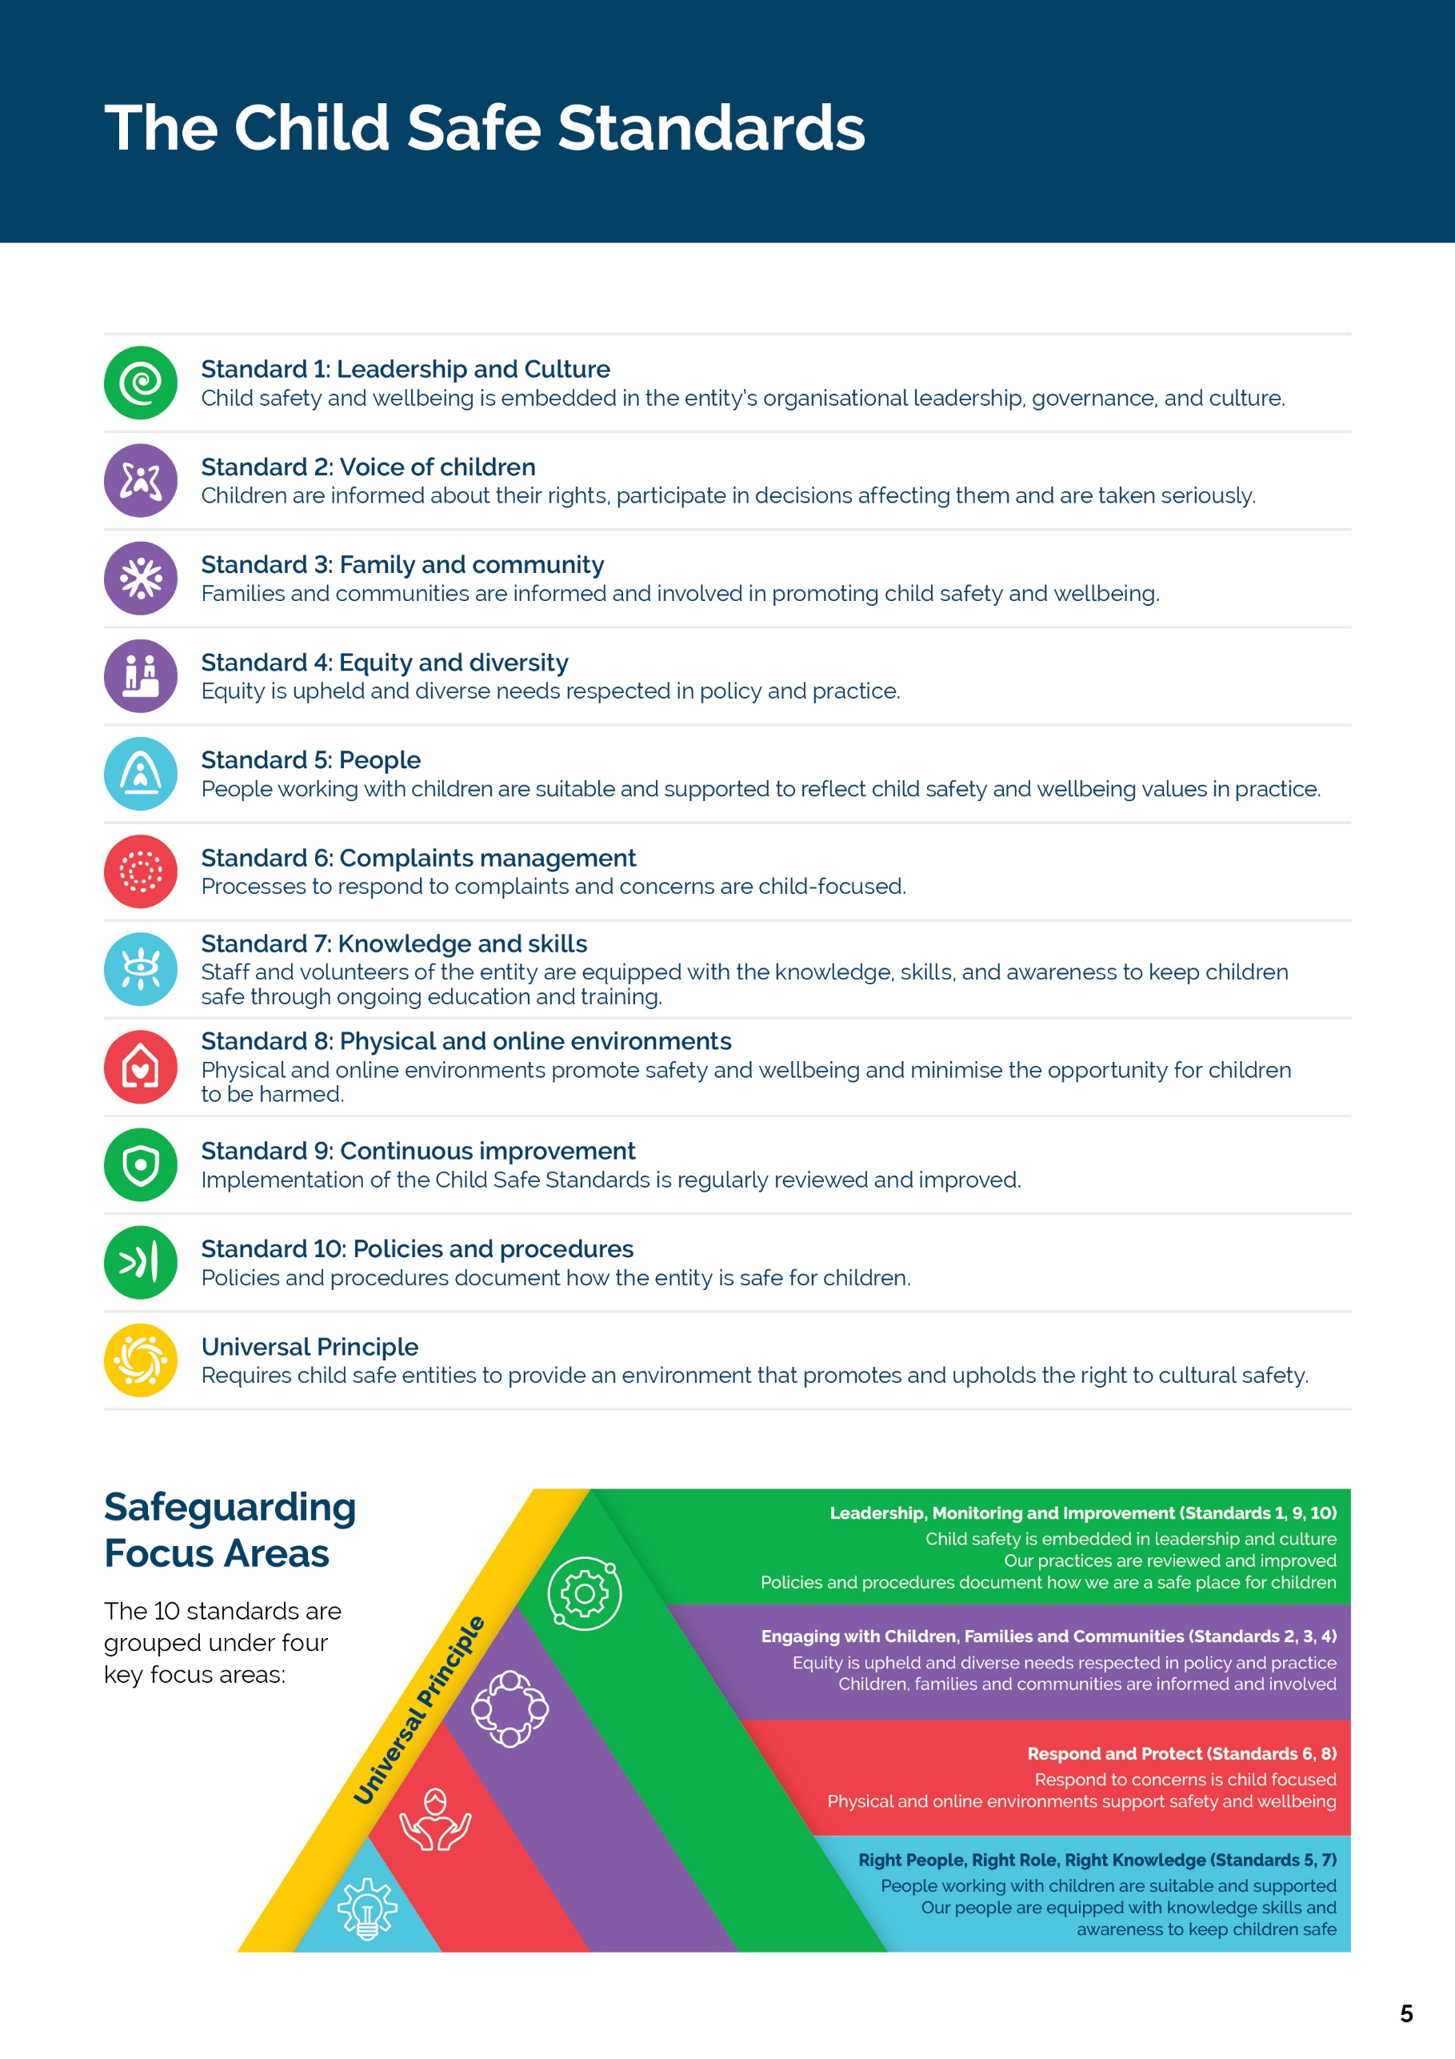

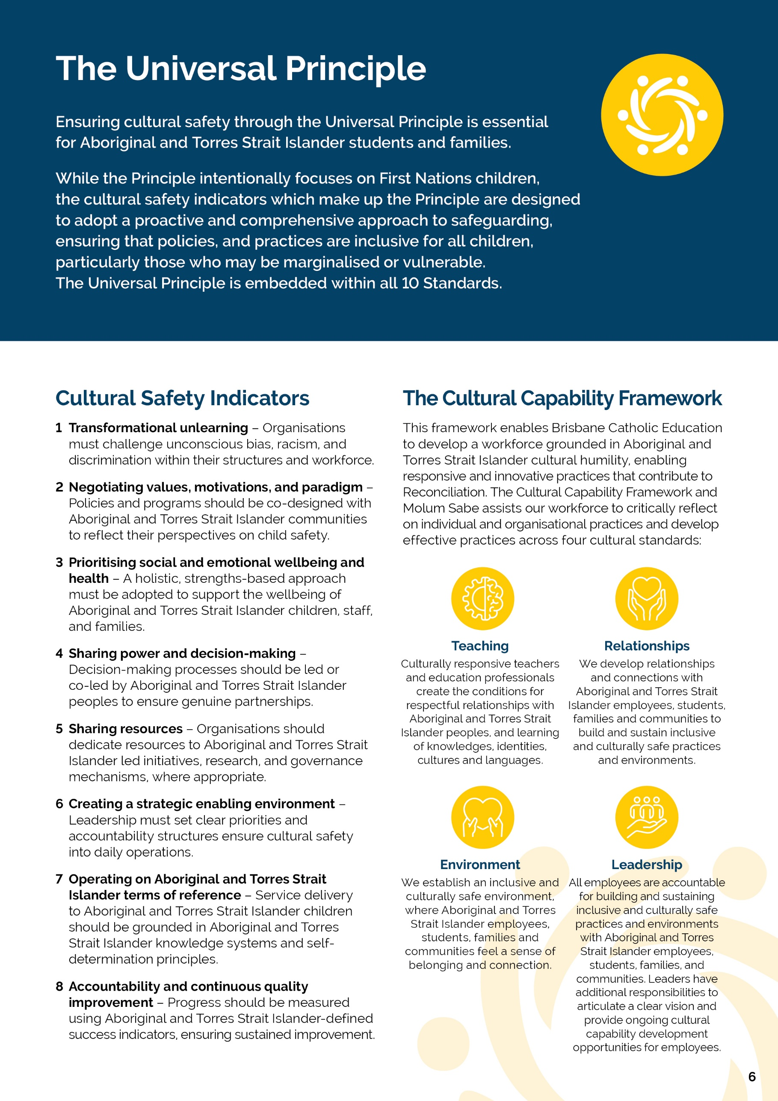
[School Name] | Safeguarding Plan 2026

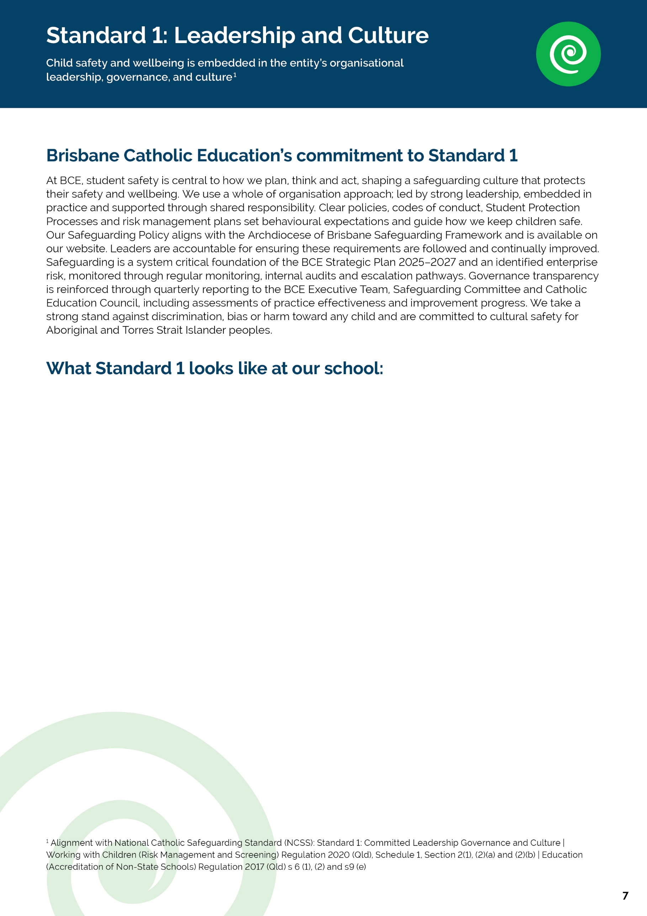
- Our College website landing page and Principal’s message promote our school as a welcoming and inclusive community, grounded in Catholic values yet welcoming to families of all backgrounds.
- The Archdiocese of Brisbane Safeguarding Commitment is displayed in the school reception. This ensures students and the wider community are regularly reminded that their safety and wellbeing are central to everything we do at Holy Family.
- The importance of Child Safeguarding is promoted at Whole School Assemblies and key events at the school including Day for Daniel activities; Child Protection Week Activities; Harmony Day and our promotion of SPC’s.
- The school leadership team is committed to a presence at the gate or on lunch time duties to welcome families and ensure students know that Holy Family staff are available and approachable.
- Before every school event, excursion, incursion, we complete a risk assessment which specifically includes considerations about students’ safety and wellbeing relevant to the activity such as supervision ratios, student privacy, transport arrangements, and consent for photos or recordings.

[School Name] | Safeguarding Plan 2026

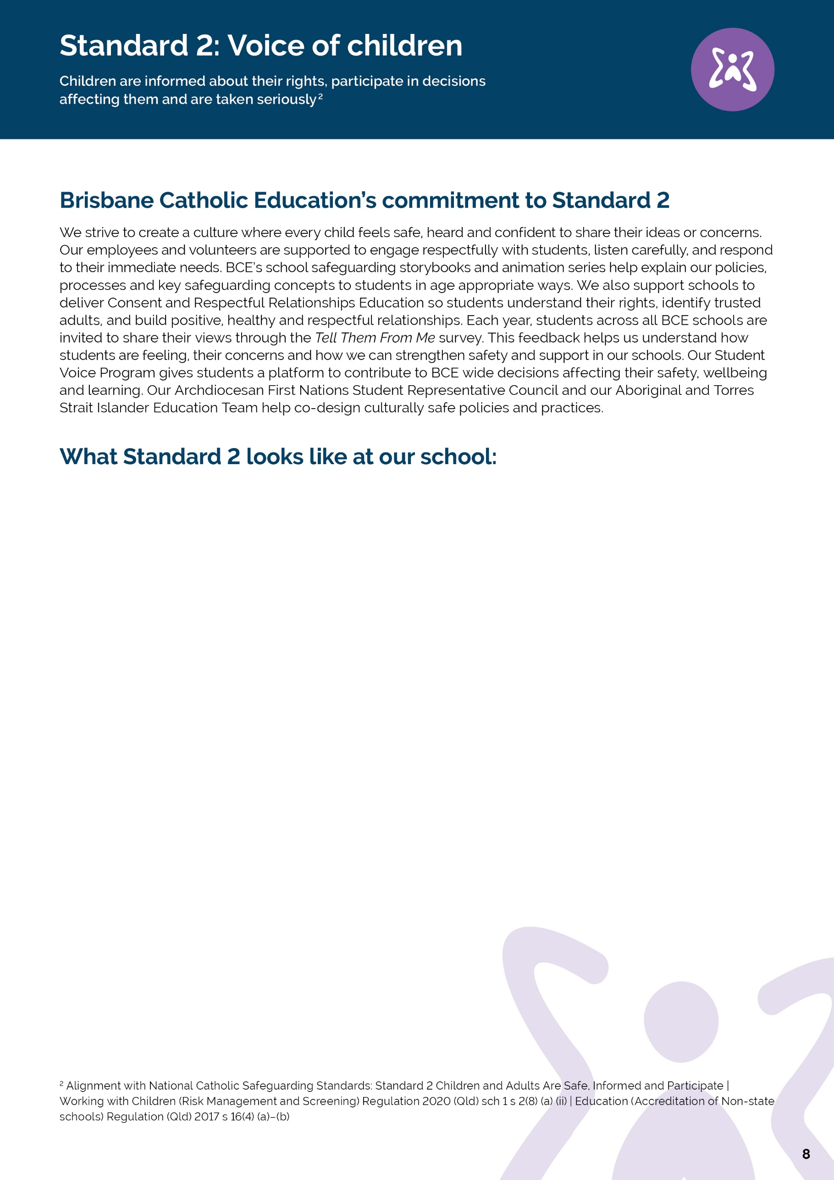
[School Name] | Safeguarding Plan 2026
- The teaching of consent, respectful relationships, and protective behaviours is evident in curriculum planning across all year levels.
- The school provides a number of opportunities outside of classroom teaching where students are able to understand consent and protective behaviours (Get Grit, Bullying, No Way Day, Daniel Morcombe Day, Child Protection Week, Library Resources – Emotional Regulation books, Rock and Water program, Friendology program and Emotional Regulation Workshops with the Guidance Counsellor).
- A regular agenda item at whole school assemblies is the reminders of our Student Protection Contacts at the school.
- All Holy Family students are considered leaders, however we encourage our Year 5’s and 6’s to take on active leadership roles by presenting short information sessions at our weekly assembly about wellbeing and safety topics – this could be in the form of a skit or presentation to keep all students engaged.
- Regular reviews of Engage data and Power BI data at Leadership meetings identifies areas of need.
- Holy Family school signage, playground design and common areas visually reinforce student safety and belonging. Our posters that are up around the school explain student rights, expected behaviours and where to get help using child-friendly language and images.
- The importance of respectful relationships is promoted through our restorative conversations following behavioural issues, allowing the person who caused harm to take responsibility and reflect on their behaviour, while also giving the person who was affected an opportunity to express how they feel and what they need moving forward.
- Holy Family’s PATH to Excellence Everyday posters provide regular reminders to students to stand up for self and others, invite others to play / join and listen attentively to others and their opinions.

[School Name] | Safeguarding Plan 2026

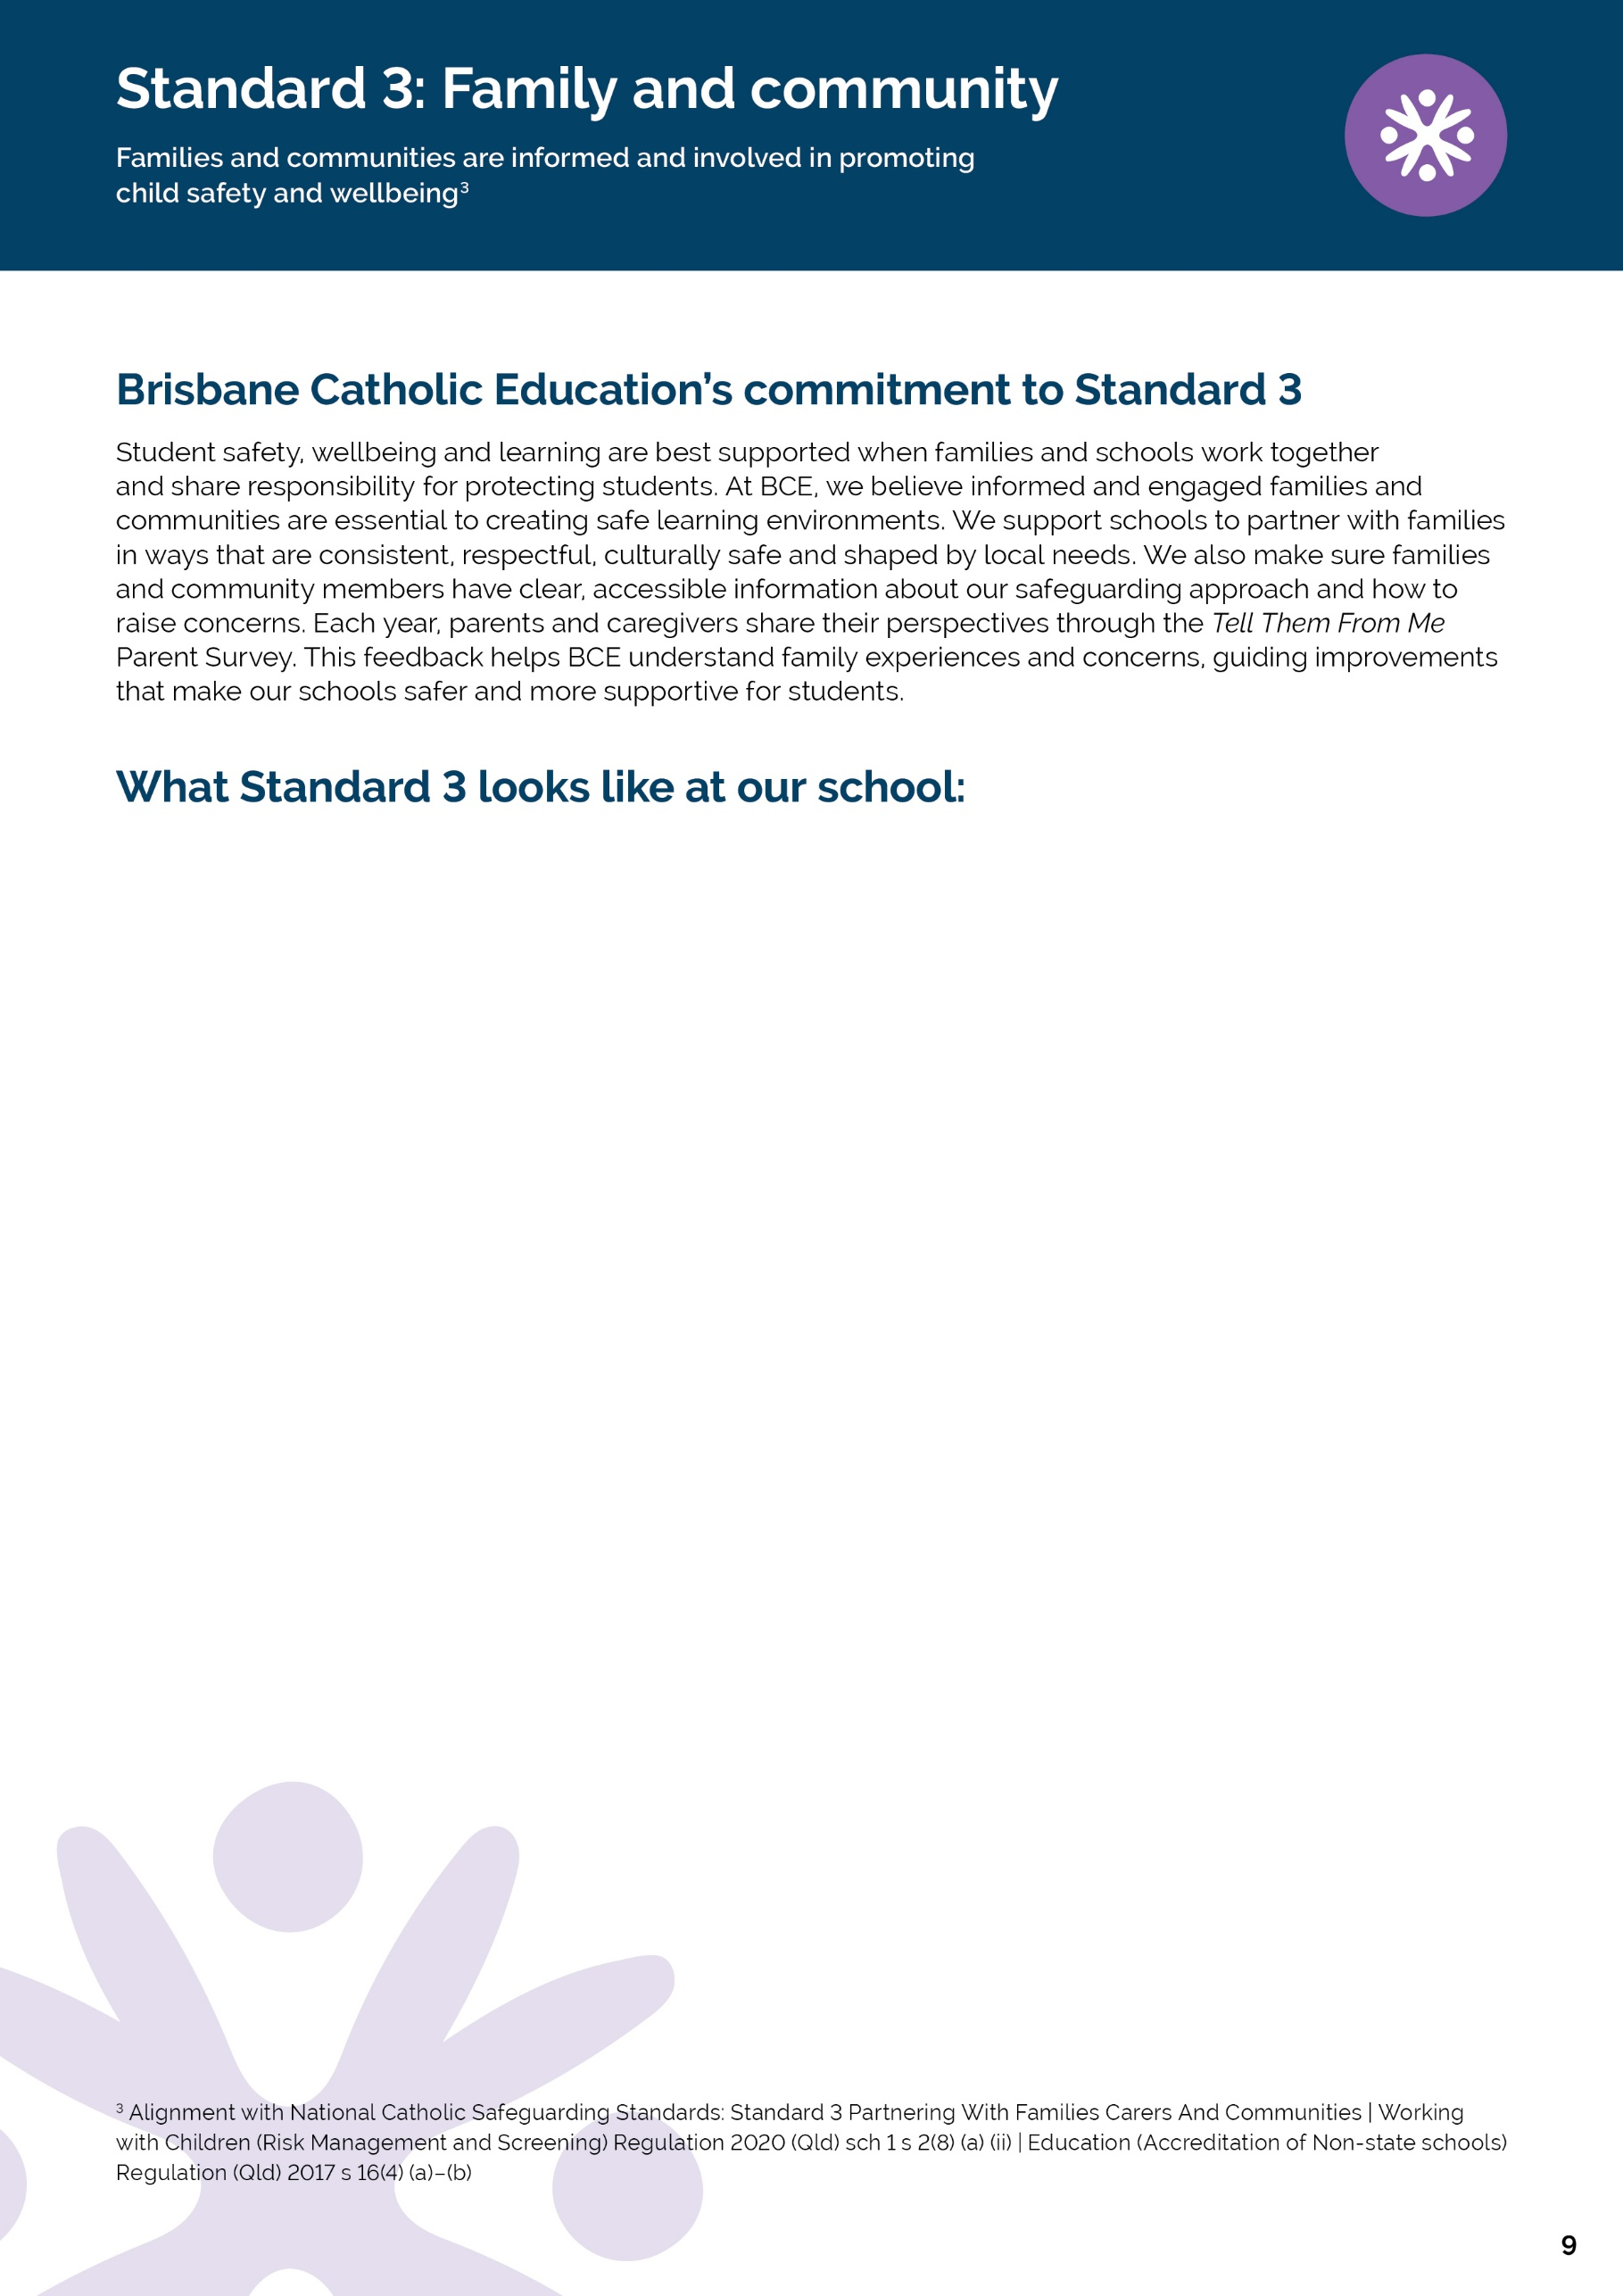
- At Holy Family, families are actively invited to participate in planning and decision-making processes that affect their child. This includes involvement in personalised learning plans, behaviour support planning, re-entry meetings following absence, and safety or wellbeing planning where required.
- Parents are informed about our safeguarding expectations through newsletters, assemblies, email communication and the Parent Welcome Evening. Holy Family creates regular, informal opportunities for connection with families through community events such as BBQs, welcome evenings, community mornings and classroom open mornings. Student safety, wellbeing and cultural safety are woven into these moments through conversation, check-ins, visibility of leadership, and shared expectations, rather than being addressed only through formal policy documents.
- Access to information, resources or tools that support families to understand our approach to student safety and wellbeing can be accessed via the website and newsletters.
- In practice, cultural safety at Holy Family is visible in everyday school routines and spaces: families can see their cultures and languages respectfully represented; staff use warm, plain language and offer yarning style conversations; cultural protocols are followed (e.g. Acknowledgement of Country and inviting guidance from local community); racism is treated as a student safety and wellbeing issue with clear, trusted pathways to raise concerns; and families are told what will happen next and who will be involved, so they feel welcomed, affirmed and confident to engage.
- At Holy Family, when behavioural incidents are escalating and a student’s needs may be linked to ADHD, trauma or other wellbeing factors, the school responds through a consistent, school-wide approach. The school relationship-based support, led by a stable team (Principal, Guidance Counsellor, classroom teacher, and Student Protection Contact), meets regularly with the family to listen to the child’s story and family context and to review supports over time. Where appropriate, students are supported to attend parts of meetings and adults clearly explain what is happening, why decisions are being made and what supports are being put in place, ensuring the student is not talked about without being considered. Together with families, staff adjust routines, expectations and learning environments. The focus shifts from “what’s wrong” to “what does this child need right now to feel safe and regulated at school”.

[School Name] | Safeguarding Plan 2026
[School Name] | Safeguarding Plan 2026

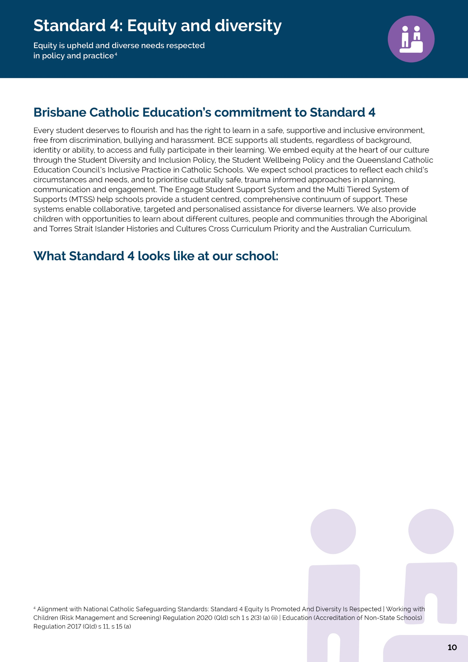
- Holy Family staff are committed to considering each student's unique circumstances before addressing issues related to behaviour, learning, or wellbeing. When needed, routines, expectations, and supports are changed to match what the student is experiencing instead of applying a uniform approach. These modifications are noted in the student’s individual support plan (if applicable), which is routinely reviewed with everyone involved: the student (in an age-appropriate way), their family, and any additional supports, including external agencies if parents provide consent. By considering these factors, we can address each child’s needs effectively and reinforce our commitment to a strong, individualised, trauma-informed approach.
- Staff at Holy Family have participated and will continue to participate in ongoing professional learning focused on trauma aware education through Berry Street.
- At Holy Family, students are regularly reminded of who they can talk to if they feel worried or unsafe. This happens through classroom discussions, assemblies, visual resources and informal conversations, rather than being limited to induction or one-off lessons.
- As a staff group we do the required Student Protection Refresher Training modules each term and then use the activities to reflect as a team how we will embed the learnings from that term’s module.
- At Holy Family, our school leadership team regularly review student protection, behaviour, wellbeing and attendance data to identify patterns and trends for student cohorts impacted by harmful behaviour. This includes reflecting on incident and process learnings and identifying strategies to reduce the likelihood of recurrence and minimise the impact of harm.
- At Holy Family, school leaders recognise that for Aboriginal and Torres Strait Islander children, feeling safe to raise concerns depends on relationships, clarity and visible signals of cultural safety, not just formal processes.
- Holy Family recognises that some students experience additional barriers to feeling safe, included and heard, and they take deliberate steps to respond to this in our operations and everyday practice. This includes recognising that children may experience overlapping identities and layered experiences and responding in ways that are supportive culturally safe, inclusive and trauma-informed, tailored to the student and their individual context.

• How the school promotes equity, inclusion and respect for diversity
• How supports and adjustments are provided for diverse learners
• How cultural safety and anti-discrimination practices are embedded
• How students access safeguarding information suitable for them
• Evidence of practice and planned improvements

[School Name] | Safeguarding Plan 2026
[School Name] | Safeguarding Plan 2026

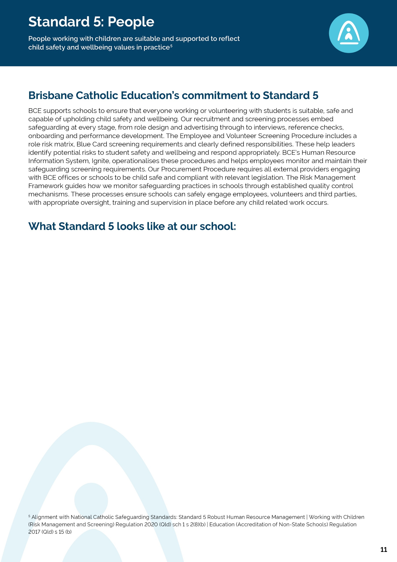
[School Name] | Safeguarding Plan 2026

In line with our implementation plan, at the end of Term 4 we will explain:

• How we screen and onboard employees, volunteers and third parties
• How we ensure safe supervision and conduct
• How we apply BCE recruitment and HR procedures for employees and volunteers
• How we track and keep safeguarding screening requirements current
• Evidence of practice and planned improvements
[School Name] | Safeguarding Plan 2026

- Holy Family Primary School promotes a child-focused and accessible approach to complaints management through Brisbane Catholic Education's complaints procedures, Student Protection Processes and our Positive Behaviour for Learning Plan.
- When concerns are raised, our leadership team, including our Student Protection Contacts use BCE complaints, student protection and behaviour procedures to guide how matters are received, escalated, documented and responded to. Staff understand when a concern can be managed at school level and when it must be escalated to BCE or external authorities. This helps ensure serious concerns are managed through the right process, by the right people, and that students and families receive a clear and consistent response.
- At Holy Family, students and families are encouraged to raise worries, concerns or complaints early, and we treat this as an important part of keeping students safe and well. Students are regularly reminded who they can speak to if they feel unsafe, worried or uncomfortable, including classroom teachers, the Guidance Counsellor, Student Protection Contacts and school leadership. These messages are reinforced through classroom conversations, assemblies, visual resources and everyday interactions so that speaking up is understood as a normal and supported part of school life.
- Concerns involving student wellbeing are addressed using restorative, supportive and trauma-informed practices that prioritise student safety, dignity and participation. Students are listened to carefully, informed about next steps, provided with ongoing support and follow-up, and given opportunities to express their views throughout the process. Through these processes, the school aims to minimise the risk of further distress, maintain positive relationships and ensure every concern is managed with the best interests, wellbeing and voice of the child at the centre of decision making.
- Holy Family is committed to cultural safety and recognises the importance of partnering with First Nations children and families in ways that are respectful and responsive to their cultural identity. Where appropriate, the school seeks guidance and support through First Nations-led perspectives, BCE support services and trusted community connections to ensure Aboriginal and Torres Strait Islander students and families feel safe, heard and supported.
[School Name] | Safeguarding Plan 2026
[School Name] | Safeguarding Plan 2026
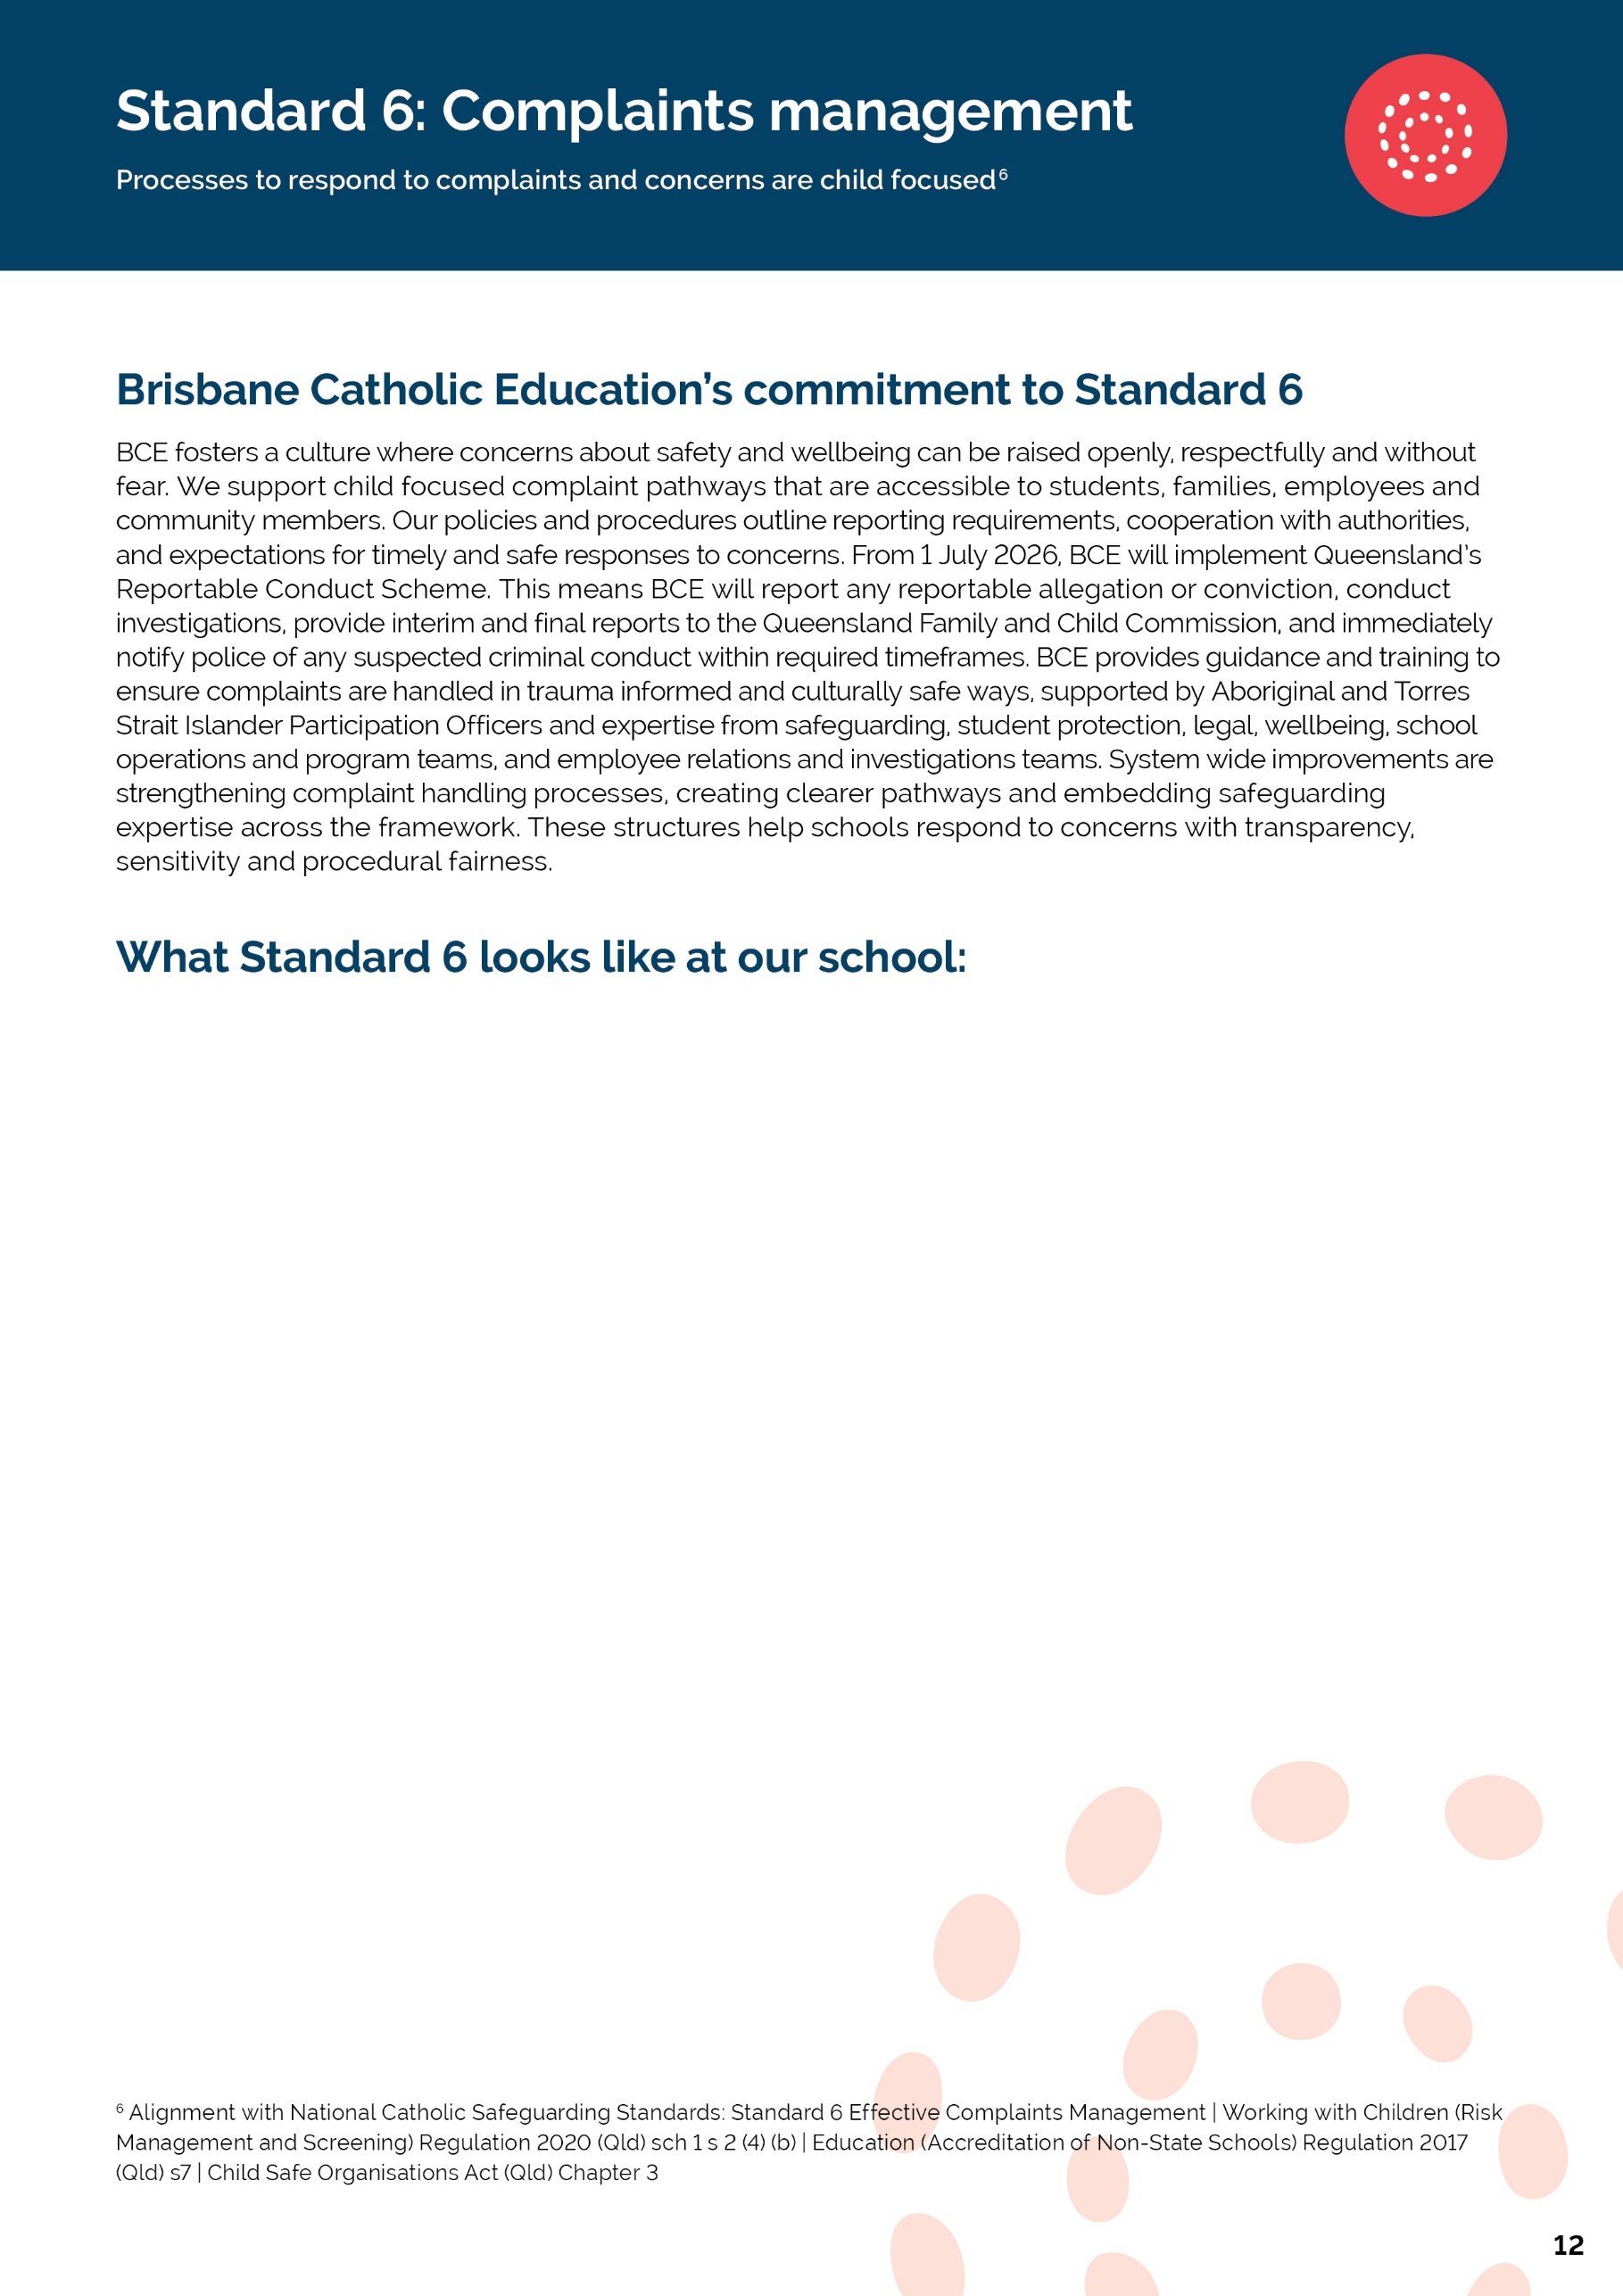

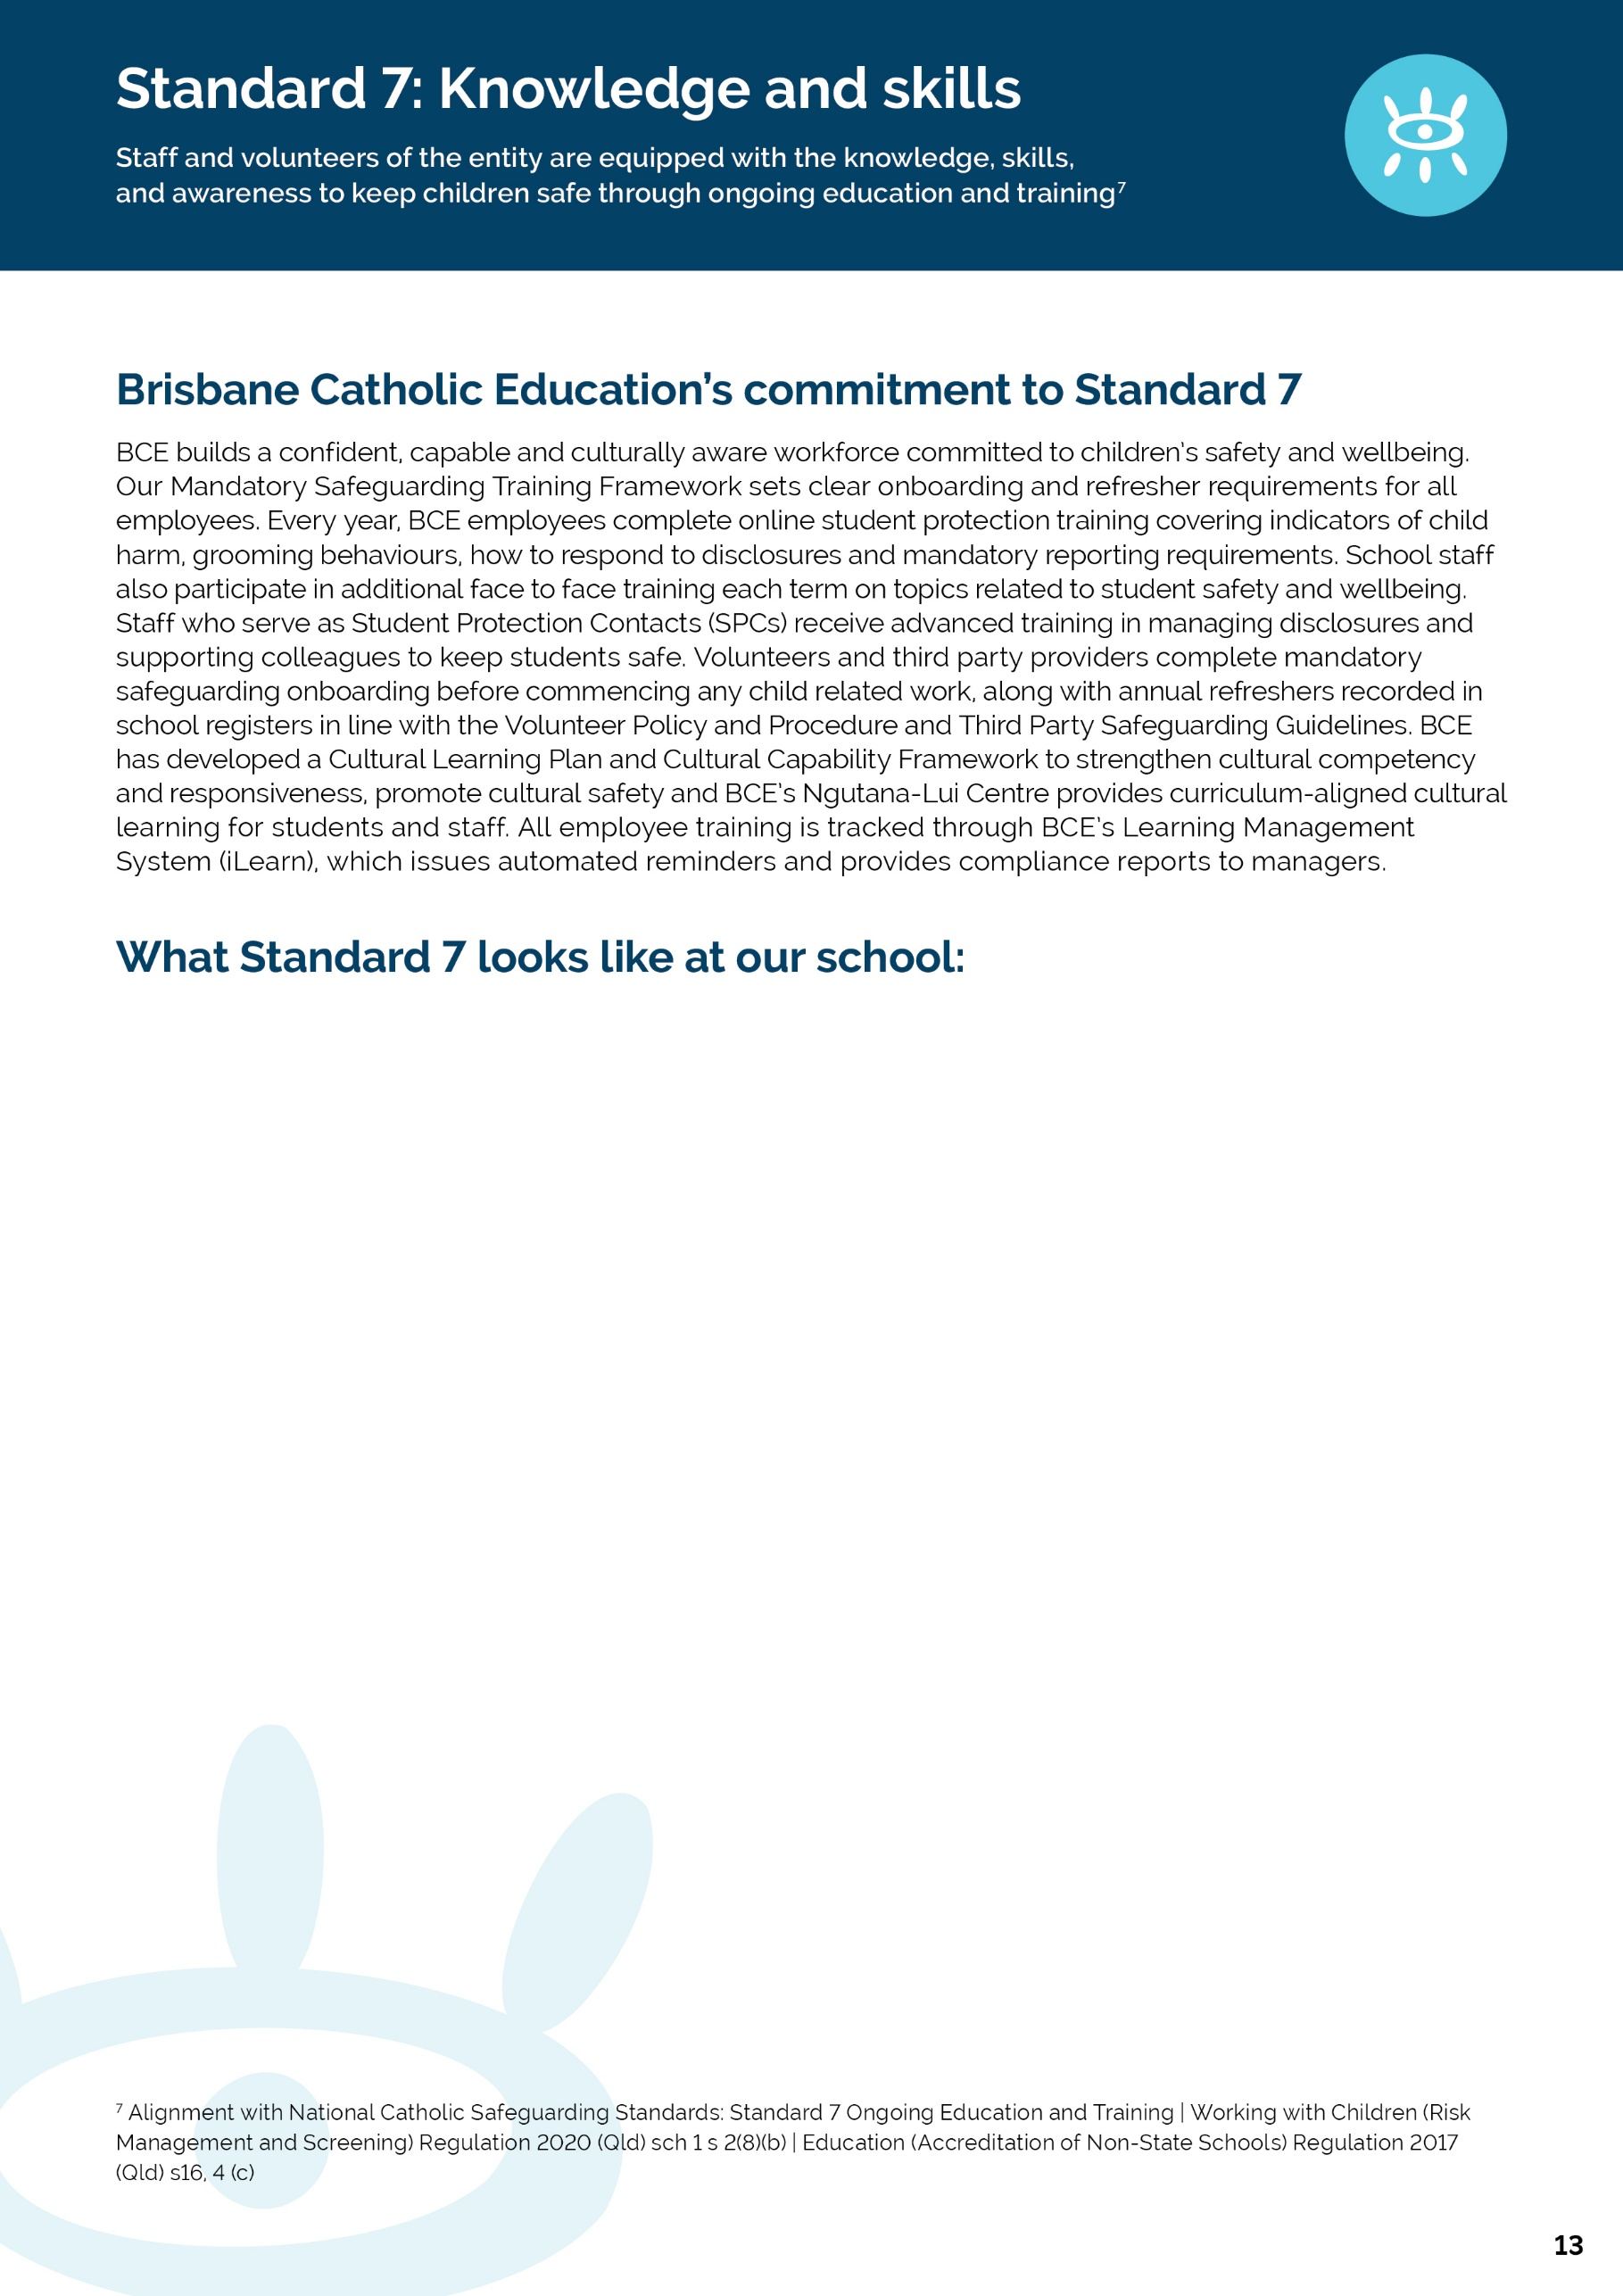
[School Name] | Safeguarding Plan 2026
In line with our implementation plan, at the end of Term 4 we will explain:
• How employees, volunteers and third parties complete required safeguarding training
• How the school reinforces safeguarding practice throughout the year
• How cultural capability is embedded in training
• How the school monitors and supports employees and volunteers to undertake mandatory training
• Evidence of practice and planned improvements
[School Name] | Safeguarding Plan 2026
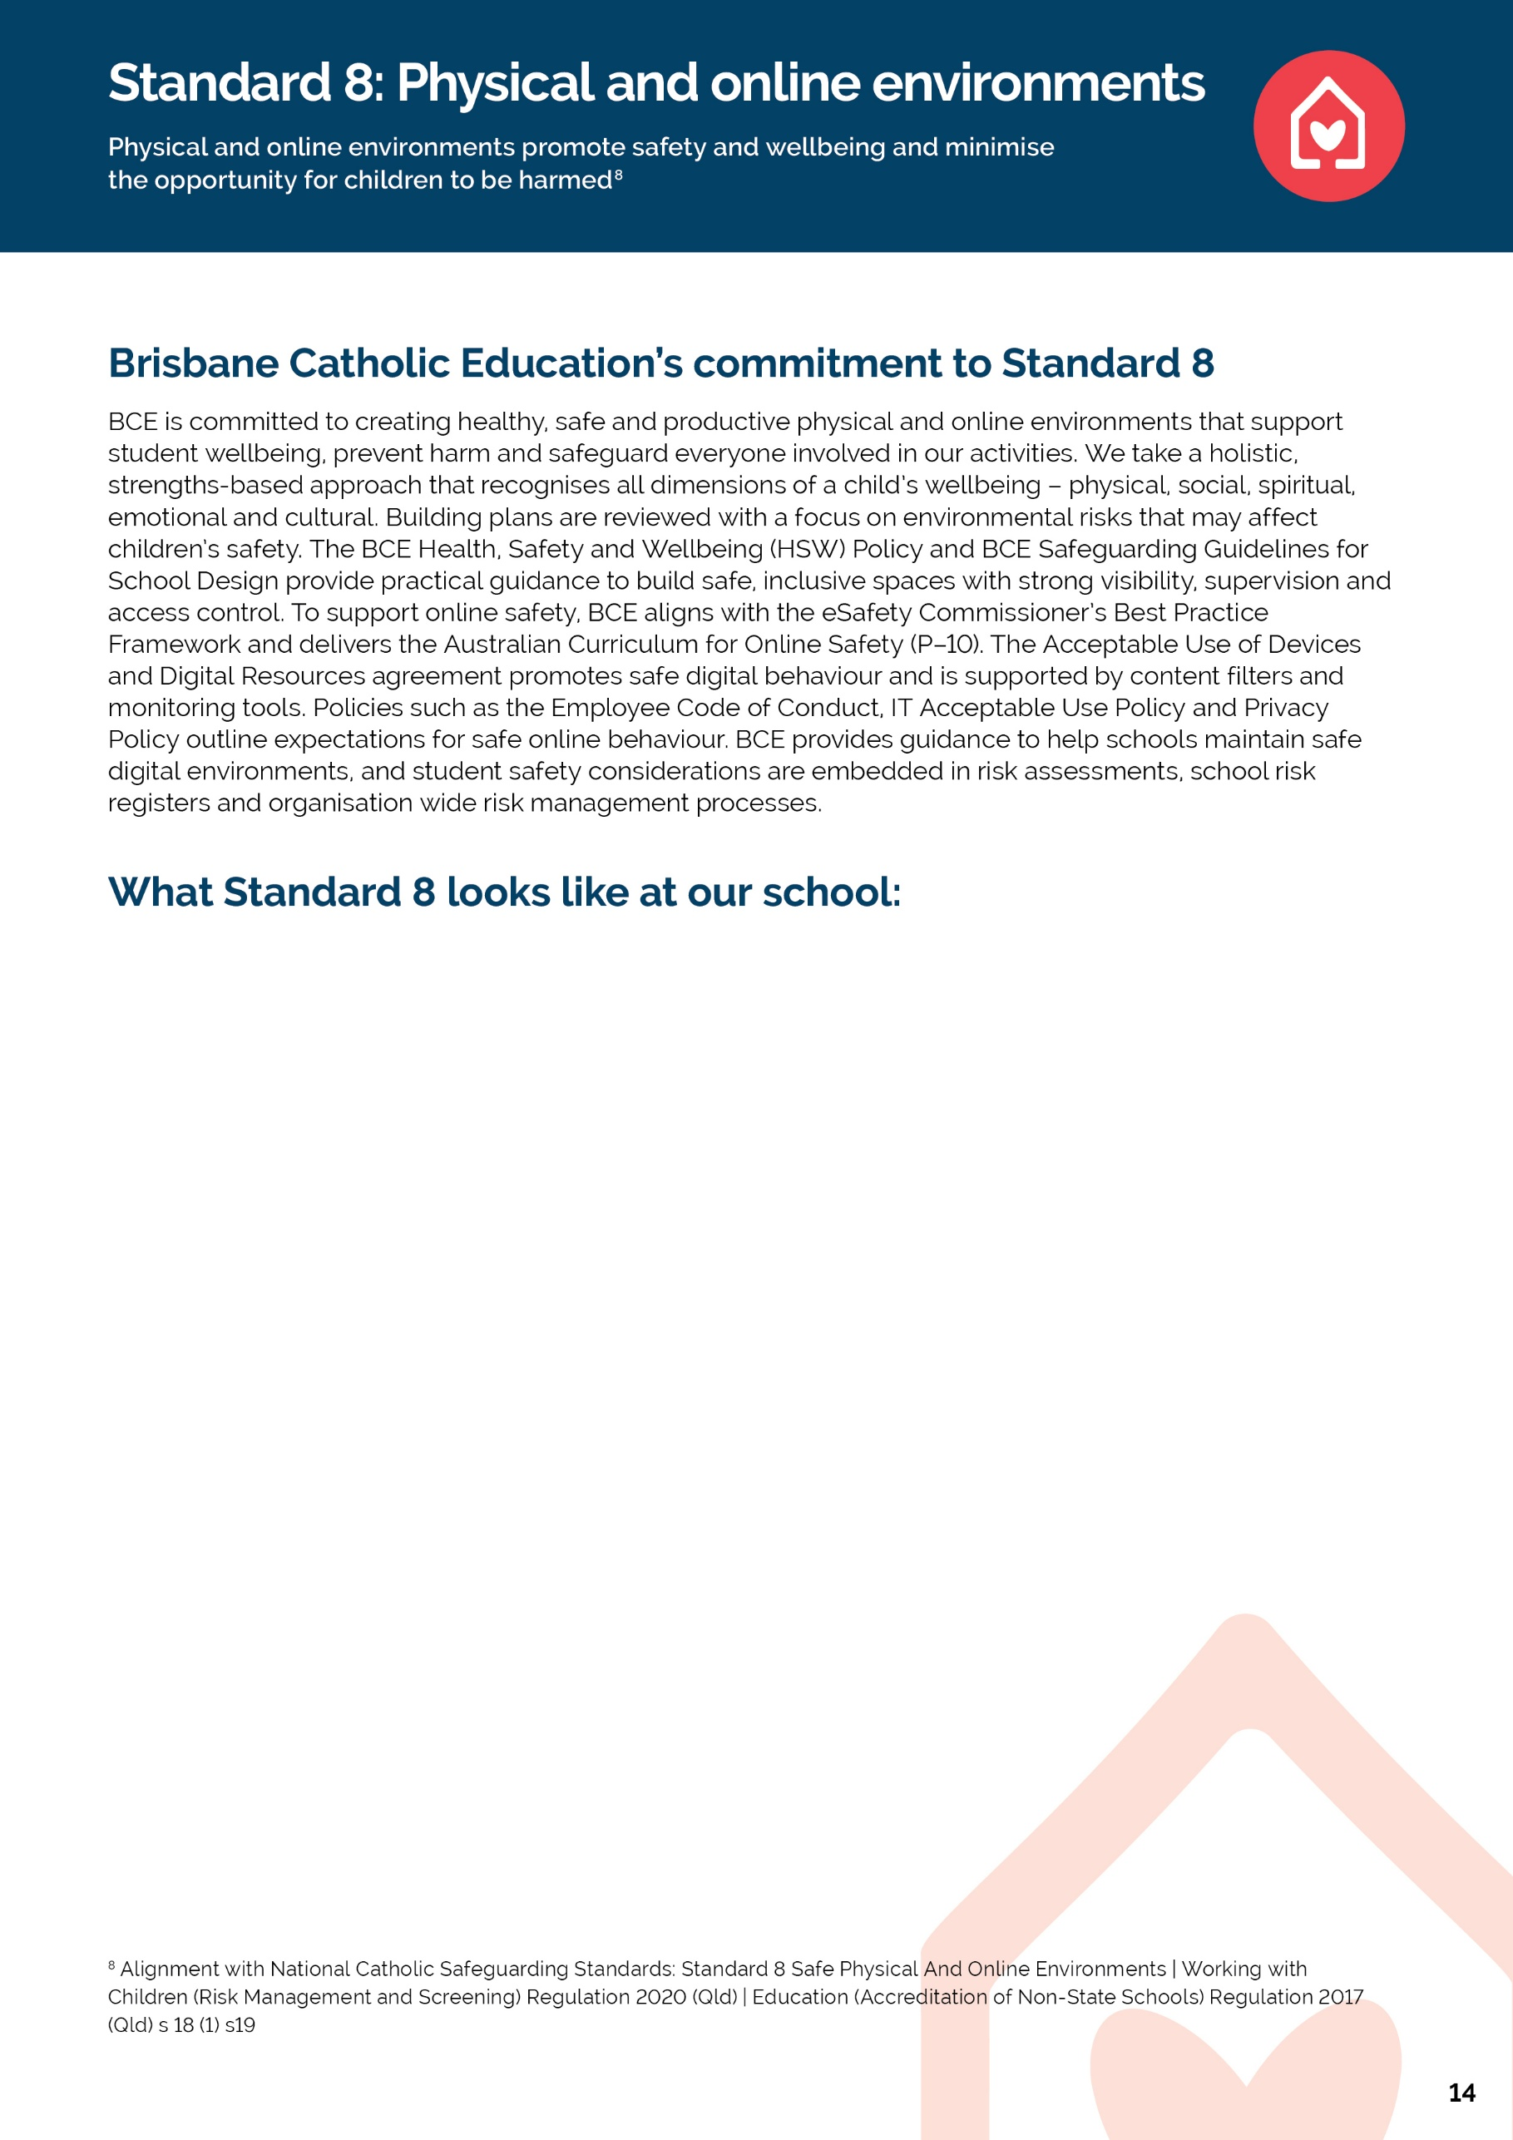
- At Holy Family Primary School, student wellbeing is embedded across learning, play, pastoral care, prayer and liturgical experiences, excursions and extra-curricular activities.
- Staff build positive relationships with students, provide access to trusted adults and support services, and make adjustments for students with additional needs. Our Catholic identity and inclusive practices promote belonging, respect, cultural safety and student voice.
- Risk assessments are completed for excursions, events and activities, with consideration given to supervision, visibility, student wellbeing, accessibility, privacy and emergency procedures. Staff follow active supervision expectations and volunteers work within clearly communicated safeguarding requirements. Student needs are considered to ensure safe and inclusive participation.
- Holy Family promotes safe technology use through approved digital platforms, acceptable use agreements and explicit teaching of cyber safety and digital citizenship. Staff respond to online concerns promptly and reinforce expectations for respectful online behaviour. Online safety information is communicated to parents and carers through school communication channels.
- The school reviews risk assessments and relevant safeguarding information when engaging external providers or using third-party facilities. Roles, supervision arrangements and safety expectations are clarified before participation, with school staff maintaining responsibility for student supervision and wellbeing throughout activities.
[School Name] | Safeguarding Plan 2026
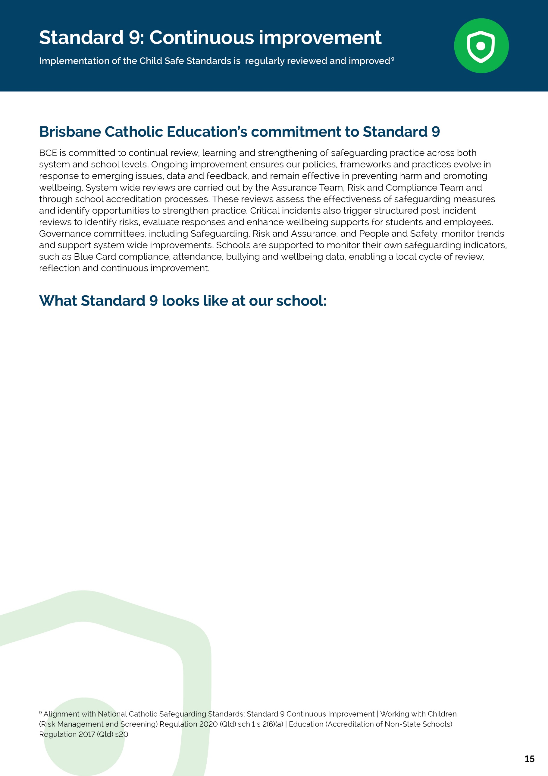
- Holy Family is currently self-assessing against the Child Safe Standards (including the Universal Principle). This involves consulting with key stakeholders, reviewing our school’s relevant safeguarding data and reflecting on our safeguarding strengths, as well as areas for improvement.
- Staff and students provide feedback on how well child safety procedures are working in real-time. This helps us identify areas needing improvement and implement changes quickly and transparently.
- Principal includes information in the school community newsletter about how the school is progressing towards their Annual Improvement Plan Goals including a strong focus on creating an inclusive and supportive community.
- Holy Family, in our Annual Improvement Plan have prioritized Multi-Tiered Support Systems, which builds a safe, predictable and supportive environment for all students, every day, including the extension of the Get GRIT program.
- PLL / ST:IE and Counsellor are involved in Enrolment Application to support students with identified needs and Student Support team meetings.
[School Name] | Safeguarding Plan 2026
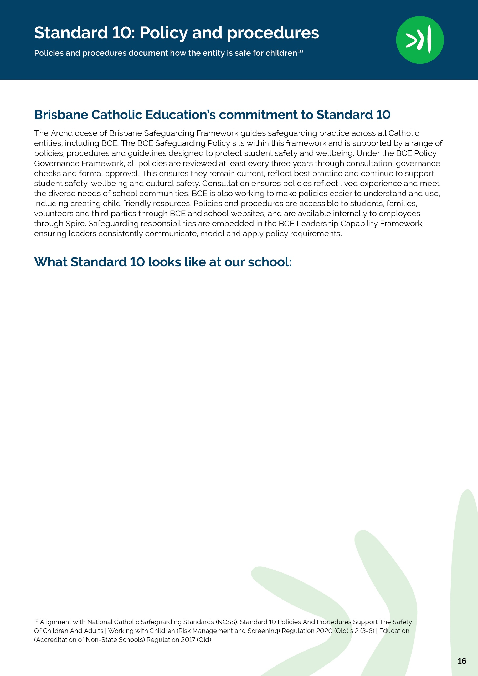
- Our onboarding process for new staff at Holy Family Primary School includes a briefing on the location, content and application of safeguarding policies and procedures and we talk through how our school is a child-safe environment (i.e. how we meet the child safe standards day to day.)
- Our staff handbook outlines safeguarding procedures in relation to evacuation and risk procedures with step-by-step instructions and flowcharts.
- At Holy Family, our leadership team regularly reinforce key safeguarding procedures and model them in everyday practice - such as always signing in visitors, maintaining appropriate boundaries and documenting significant events.
- Holy Family’s Leadership Team and Guidance Counsellor confer regularly on current student protection matters and ensure student safety remains a top priority, actions are clearly documented and that the Student Protection Contacts are responding to student protection matters in line with the Student Protection Processes and Guidelines.
- All staff at Holy Family complete an annual safeguarding refresher that includes scenario based learning, ensuring they understand how to apply policies in real world situations. This supports consistent implementation across the school.
- All people who volunteer at Holy Family receive a brief orientation before beginning their role, which reinforces the information they get in their mandatory training includes clear guidance on appropriate interactions, supervision expectations, and what to do if they are worried about a student. This helps ensure volunteers uphold the same standards as paid staff.
- Teachers incorporate reminders of key safeguarding practices into daily routines - for example, ensuring students know who the SPCs are at Holy Family by pointing out their photos on the SPC posters that are in each classroom, reviewing safe movement procedures, and modelling respectful communication.
[School Name] | Safeguarding Plan 2026


